Finding Us

Loughborough Wellbeing Centre
Ground floor, Asha House
63 Woodgate
Loughborough, LE11 2TZ

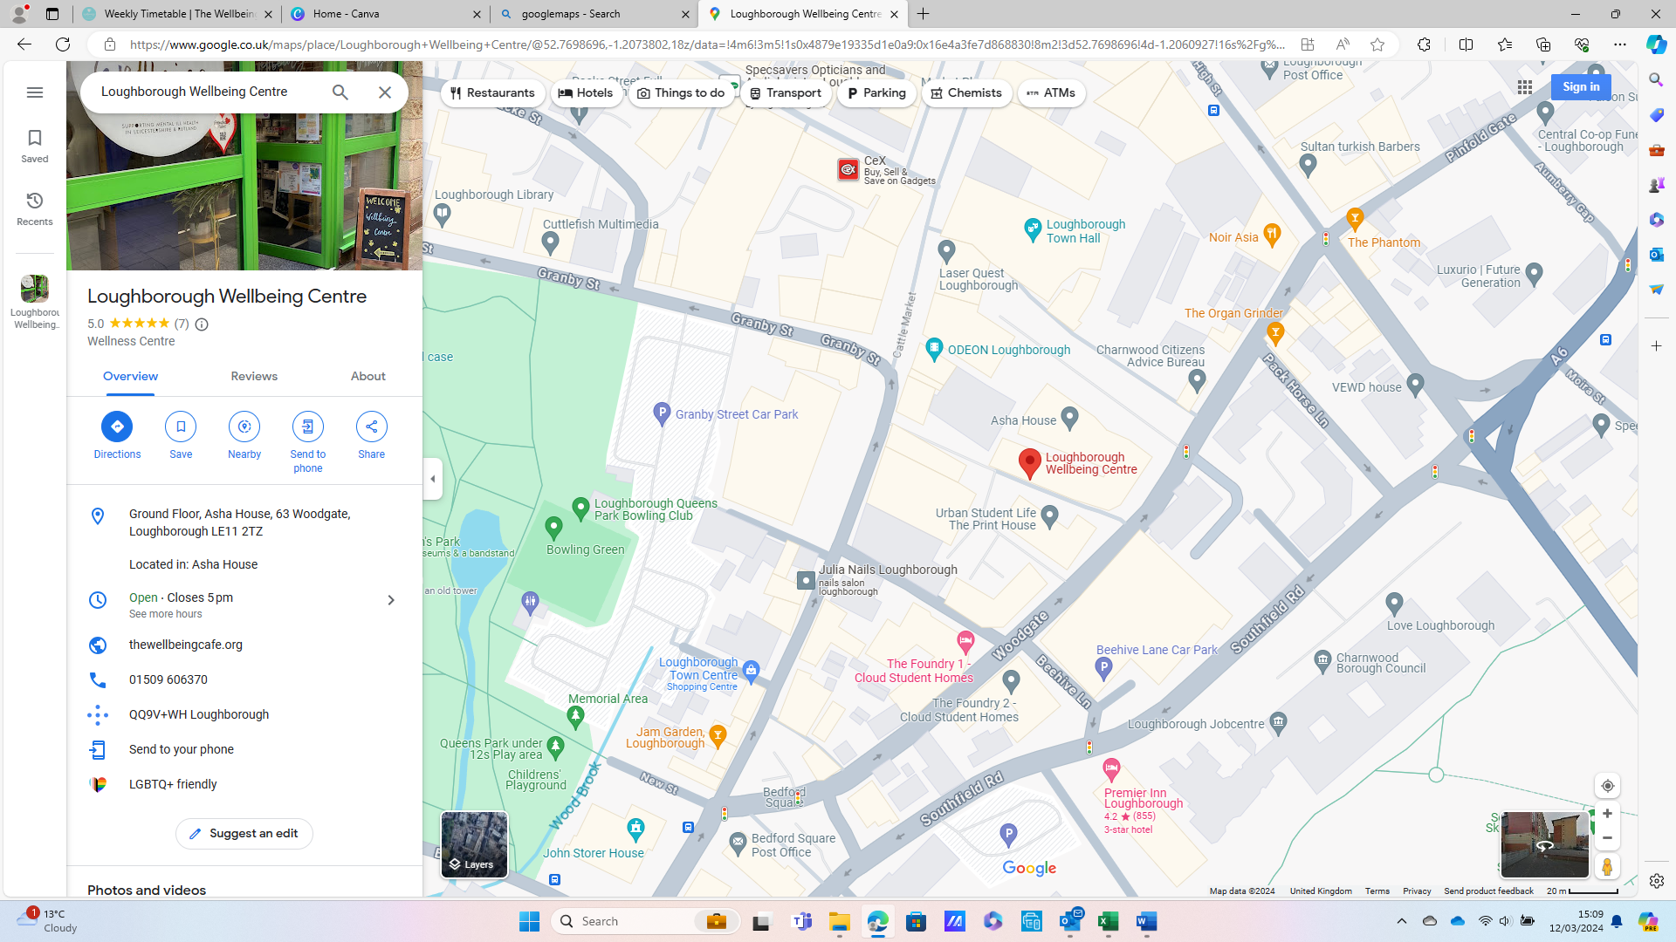

We are located on an alley between the Beehive car park and Loughborough town centre.
From the car park, cross over at the pedestrian crossing then go down the alley between the Wheeltapper pub and Asha House. You will see the Wellbeing Centre on your right-hand side.
From the town centre, the alley can be found between Co-op funeral care and Cashino, opposite Devonshire Fisheries.
Recommended parking:
Beehive Multi-story car park, Beehive lane, LE11 2TS
Browns Lane car park, Browns Lane, LE11 3HE
Public transport:
Closest bus stop south towards Leicester: Bus 127 from A6, opposite Aumberry Gap
Buses towards Shepshed: Bus 127 from Baxter Gate
